ISMUNHK 2017-2018

UNESCO CHAIR REPORT



TOPIC: The safeguarding and preservation of UNESCO World Heritage Sites

By **Ricky Shi**

# **Contents**

## Introduction 3

## Key Terms 4

## Background Information 5

## Key Areas 7

## Guiding Questions 8

## Key Parties Involved 9

## Timeline 11

## Possible Solutions 12

## Further Research 13

## Bibliography 14

## 

## 

## 

## 

## 

## **Introduction**

Culture leads to peace and development, and the loss of culture ultimately is bad for all of us. World Heritage Sites recognized by UNESCO all provide a high amount of culture to our world, increasing global tolerance. However, there are some sites which are in danger, in particular natural sites. Armed conflict and war, earthquakes and other natural disasters, pollution, poaching, uncontrolled urbanization and unchecked tourist development all pose major problems to World Heritage sites.

The loss of such sites would also be a huge loss for humanity, our heritage, and would prevent future generations from being able to view the natural wonders of planet Earth. When humanity’s development has inflicted injury to mother nature, it is high time we take some action. UNESCO should discuss ways to safekeep these World Heritage Sites while balancing the need for development and gentrification.

# 

# 

# 

# 

# 

# 

# 

# **Key Terms**

**Uncontrolled Urbanization**

* Usually in the form of land degradation, with resulting natural hazards caused by uncontrolled human development activities, including unauthorized landfills, deforestation, unplanned land‐use and the uncontrolled expansion of the urban landscape.

**Urbanization**

* The process of making an area more **urban** or the development of an area to be more city-like

**Monitoring**

* One of the essential functions of the World Heritage Committee is to monitor the state of conservation of properties inscribed in the World Heritage List.
* To monitor something is to consistently watch over it and keep updated about its status

**Natural Heritage**

* For the purposes of this Convention, the following shall be considered as "natural heritage": natural features consisting of physical and biological formations or groups of such formations, which are of outstanding universal value from the aesthetici or scientific point of view; geological and physiographical formations and precisely delineated areas which constitute the habitat of threatened species of animals and plants of outstanding universal value from the point of view of science or conservation; natural sites or precisely delineated natural areas of outstanding universal value from the point of view of science, conservation, or natural beauty (UNESCO 1972).

**Preservation**

* One of the main purposes of the World Heritage Sites designation is to encourage, almost mandate, the preservation of such a site.
* To preserve something in this case would be to prolong its current state for as long as possible, usually for the purpose of allowing future generations to see.

**International Cooperation**

* International cooperation is another huge issue in regards to WHSites. The UN works through UNESCO to authorize UN agencies, especially the WHC to set guidelines and rules for countries to follow to protect WHSites.

**World Heritage Site**

* According to the UNESCO, a World Heritage Site is defined as a natural or man-made site, area, or structure recognized as being of outstanding international importance and therefore as deserving special protection

**World Heritage Convention**

* The World Heritage Convention is an international treaty adopted by UNESCO’S General Conference in 1972. Its main purpose is the identification and collective protection of the world’s cultural and natural heritage considered to be of ‘outstanding universal value’

# **Background Information**

# In the year of 1954, Egypt decided to build the new Aswan High Dam, the resulting reservoir would eventually flood a large stretch of the Nile valley containing many precious cultural treasures of ancient Egypt and ancient Nubia. In the year of 1959, both the Egyptian and Sudanese government made a request to UNESCO for assistance for their countries to protect and rescue the endangered monuments and sites. In the year of 1960, the Director-General of UNESCO gave launch to an appeal aimed at the UN member states for an “International Campaign to Save the Monuments of Nubia”. Such an appeal resulted in the excavation and recording of many hundreds of sites, recovering many thousands of objects, as well as salvaging and relocating a number of important temples to higher ground. Two pretty famous ones are the temple complexes of Abu Simbel and Philae. The campaign, which ended in 1980, was to be considered a success. As tokens of Egypt gratitude to countries which contributed to the campaign's success, they donated four temples to be relocated to countries who contributed to their preservation

The project's success led to other safeguarding campaigns: saving Venice and its lagoon in Italy, the ruins of Mohenjo-daro in Pakistan, and the Borobudur Temple Compounds in Indonesia. UNESCO then drafted, with the help of ICOMOS, a convention to protect the cultural heritage that is deeply rooted in humanity.

The United States (in their usual attitude of meddling) initiated the idea of cultural and natural conservation. A White House conference in the year of 1965 called for a "World Heritage Trust" to preserve “the world's superb natural and scenic areas and historic sites for the present and the future of the entire world citizenry,” whatever that means. The IUCN worked on similar proposals in 1968, and they were presented in 1972 to the United Nations Conference on the Human Environment, in Stockholm. Under the World Heritage Committee, signatory countries were required to produce and submit periodical data reporting on and providing the WHC with overviews of each nation's implementation of the WHC and updates of current conditions at World Heritage properties.

A single reso was agreed on by all parties, and the "Convention Concerning the Protection of the World Cultural and Natural Heritage" was adopted by the General Conference of UNESCO on the 16th November 1972.

The Convention was applied to the world on 17 December 1975, and as of May 2017, it has been ratified by 193 states/parties, including 189 UN member states, with the Cook Islands, the Holy See, Niue, and the State of Palestine as well. Only four stubborn UN member states have not ratified the Convention: Liechtenstein, Nauru, Somalia and Tuvalu. What a mean bunch of countries!

However, even after the signing of so many tedious documents and many decades spent on making a solution, politicians have triumphed and the issue still exists today. The issue being referred to, of course, is the fact that World Heritage Sites are still being put at risk, due to abandonment, overpopulation of tourists, careless expansion of cities, climate change, and war just to list a few. A more specific example would be those Heritage Sites located in the Middle East, with warring countries like Syria, Libya, or Yemen posing as grave threats to our Heritage Sites. Another would be severe pollution massacring the plants and animals at the Everglades National Park, resulting in the severe degradation of this World Heritage Site.

To help raise awareness amongst individuals, organizations, and governments, UNESCO had created a list of World Heritage Sites, aptly named the “List of World Heritage in Danger”, alongside the World Heritage Site scheme in 1972. This helped raise awareness about World Heritage Sites at risk, meaning that it was in a state which was prone to severe deterioration, thus preventing future generations from seeing them.

However, this has not prevented the sites listed on the list to almost double (from 27 to 54) since the turn of the century, the greatest increase since the establishment of the list and the World Heritage Sites program.

**Key Areas**

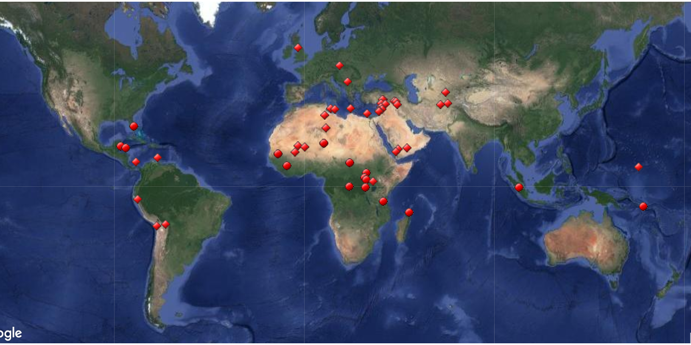

(above) World Heritage Sites in Danger, according to the List of World Heritage in Danger, by UNESCO and the WHC

Since the main issue at hand here is the preservation of World Heritage Sites at risk, the Key Areas in question would be such Heritage Sites. However, as there are 54 such sites, it would be impractical to list all of them, above is a map to give a general idea of the severity at hand. The actual official list contains a very detailed explanation for all 54 such sites. The list can be accessed by going to: [whc.unesco.org/en/danger/](https://whc.unesco.org/en/danger/)

# 

# 

# **Guiding Questions**

1. How can existing heritages sites in current conflict/polluted/under urbanization/tourist areas be better secured?
2. What measures should/could the international community address, and what are best left up to individual states?
3. Are current measures providing sufficient protection or should member states enact additional ones?
4. Under what circumstances is it appropriate for the international community to intervene to prevent the destruction of world heritages sites? Does sovereignty play any role?
5. Are there currently enough regulations for heritage sites to protect their integrity?

# 

# 

# 

# 

# **Key Parties Involved**

**The United Nations**

* UNESCO
  + The UNESCO has an essential role to play in supporting Member States to prepare for, respond to the issue of protecting World Heritage Sites. It is within this committee that the WHC was created to further specialize the conservation of our heritage, and mother nature’s wonders.
* World Heritage Convention
  + The WHC covers a wide range of topics regarding the labeling, management, monitoring, and protection of World Heritage Sites.

**The European Union**

* Europe: The rich culture of the European continent has been protected rigorously from damage, and efforts to maintain sites have been mostly effective. In **Italy**, which boasts **the highest number of World Heritage Sites** in a single country, efforts to restore sites are considered a priority, given the revenue they generate through tourism. This strong attachment to culture has led the continent to deplore the destruction of any site, in line with UNESCO’s policy to condemn any meditated attempt to destroy world heritage. In conflict zones, the destruction of world heritage sites becomes a difficult issue, as in European military actions, the regard for heritage is very limited, but not insignificant. Officially, European countries have committed to the preservation of sites, but this policy is easily overshadowed by geopolitical priorities. Interestingly, however, the protection of culture is such a critical European value that the destruction of sites in a foreign conflict plays a not fully insignificant role in European decision to embark on a humanitarian intervention. (Convention for the Protection of Cultural Property in the Event of Armed Conflict with Regulations for the Execution of the Convention 1954, Article 7.)

**International Council on Monuments and Sites**

* ICOMOS is an international non governmental organisation that is comprised of professionals, experts, representatives from local authorities, companies and heritage organisations, and has been continuously dedicated to the conservation and enhancement of the architectural and landscape heritage throughout the world since 1965.

**The United States of America**

* The US condemns the destruction of World Heritage Sites, perhaps not to the degree of Europe, but nonetheless considers it a fundamental issue requiring international attention. The existence of such groups as the “American Association of Museums” and the “American Alliance of Museums” is testament to the commitment towards the preservation of heritage both domestically and abroad. It is clear that the US is fundamentally against any illicit arms trade, and therefore any revenue accumulated by pernicious parties as a result of selling artifacts is viewed negatively.

**The African Union**

* The African Union has long been in support of the World Heritage movement. As the African continent contains a great many of the world’s significant Heritage Sites, both in the form of ancient human constructs and nature’s wonders.
* African World Heritage Fund
  + Funds such as this are a testament to the AU’s long-standing commitment towards the preservation of World Heritage Sites

# 

# 

# 

# 

# 

# 

# 

# 

# 

# **Timeline**

|  |  |
| --- | --- |
| Date | Event |
| 1954 | Egypt builds dam, ruins many treasures, historical structures, and ancient artifacts |
| 1959 | Egypt + Sudan request for help, because they ruined their Heritage Sites (this is before World Heritage Sites were a thing) |
| 1960 | Director-General of UNESCO laid the ground works for the planning process of what would later become the World Heritage Convention |
| 1965 | The White House called for a "World Heritage Trust" to preserve “the world's superb natural and scenic areas and historic sites for the present and the future of the entire world citizenry,” whatever that means. |
| 1968 | The IUCN worked on proposals similar to the previous ones. |
| 1972 | Proposals were presented to the United Nations Conference on the Human Environment, in Stockholm. |
| 1972 | The “List of World Heritage in Danger” was established. |
| Nov. 16, 1972 | The "Convention Concerning the Protection of the World Cultural and Natural Heritage" was adopted by the General Conference of UNESCO. |
| Dec. 17, 1975 | The Convention was Enacted. |
| May 2017 | All except 4 countries have ratified the Convention. |
| 2017 | 54 Sites are listed on the “List of World Heritage in Danger”. |

# 

# 

# 

# 

# **Possible Solutions**

1. Better communication and coordination among Member States
   1. The first key issue to address is the inherent lack of coordination amongst the various international conventions and accords (such as the Hague Convention). While many sound points have been made, the inherent bias of past agreements has led to a lack of coordination amongst Members States in their efforts to protect world heritage. These outdated documents could potentially redrafted to suit contemporary issues, most notably the question of (violent) Non-state Actors. How best to account for situations in which a conflict is carried out with such groups is critical to the protection of sites. The main challenges would be the consideration and respect of each Member’s sovereignty, their stance/beliefs, and the logistics of planning such coordination. There is a clear need of more efforts to preserve our World Heritage Sites
2. Encouraging ratification of current conventions/treaties/resos, modifying them to cope with the times, and creating new ones to address the changing climates along with the pollution that causes it:
   1. Pollution has been at the heart of so so many of our society’s problems. However, more can be done to stop it from increasing, specifically in its significant role in causing the rapid recent deterioration of many many natural Heritage Sites. With countries like the US pulling out of important treaties like the Paris Agreement, the rate of ruin for our precious natural wonders has never been further from reduction. By fixing our pollution, we at least enable mother nature to fix our climate. And only once that’s done, can any meaningful preservation begin happen to our natural and/or even our human Heritage Sites.

# **Further research suggestions**

<https://whc.unesco.org/en/danger/> - This is really all you need in general, it contains descriptions of all the Sites in danger. Everything else that is specific to your own country (stance or otherwise) is really just a quick Google search away.

# 

# **Bibliography**

“Glossary of World Heritage Terms.” *UNESCO World Heritage Centre*, UNESCO, whc.unesco.org/archive/gloss96.htm.

“List of World Heritage in Danger.” *Wikipedia*, Wikimedia Foundation, 20 May 2018, en.wikipedia.org/wiki/List_of_World_Heritage_in_Danger.

“Supporting Cultural Heritage - Culture - European Commission.” *Social Protection Statistics - Unemployment Benefits - Statistics Explained*, 12 Mar. 2012, ec.europa.eu/culture/policy/culture-policies/cultural-heritage_en.

“The National Park Service: Preserving the Places and Stories of America's Diverse Cultural Heritage---Places Reflecting America's Diverse Cultures Explore Their Stories in the National Park System: A Discover Our Shared Heritage Travel Itinerary.” *National Parks Service*, U.S. Department of the Interior, www.nps.gov/nr/travel/cultural_diversity/Preserving_the_Places_and_Stories_of_Americas_Diverse_Cultural Heritage.html.

UNESCO World Heritage Centre. “List of World Heritage in Danger.” *UNESCO World Heritage Centre*, whc.unesco.org/en/danger/.

UNESCO World Heritage Centre. “World Heritage in Danger.” *UNESCO World Heritage Centre*, whc.unesco.org/en/158/.

UNESCO World Heritage Centre. “World Heritage List Statistics.” *UNESCO World Heritage Centre*, whc.unesco.org/en/list/stat/#s7.

“World Heritage Site.” *Wikipedia*, Wikimedia Foundation, 15 May 2018, en.wikipedia.org/wiki/World_Heritage_Site.